How I implemented the first names, last names, and positions:

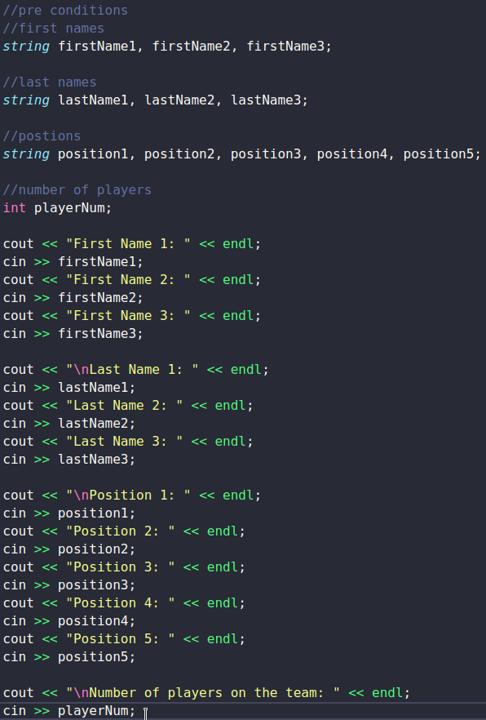

How I randomized the names and positions:

Here’s the names -

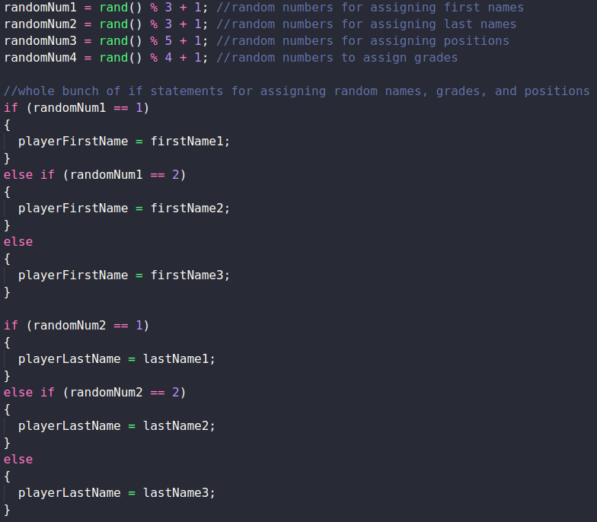

Here’s the positions -

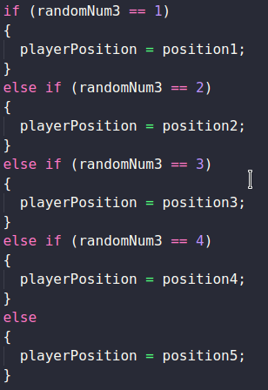

Here is the options and prices:

Picture 1 of 2

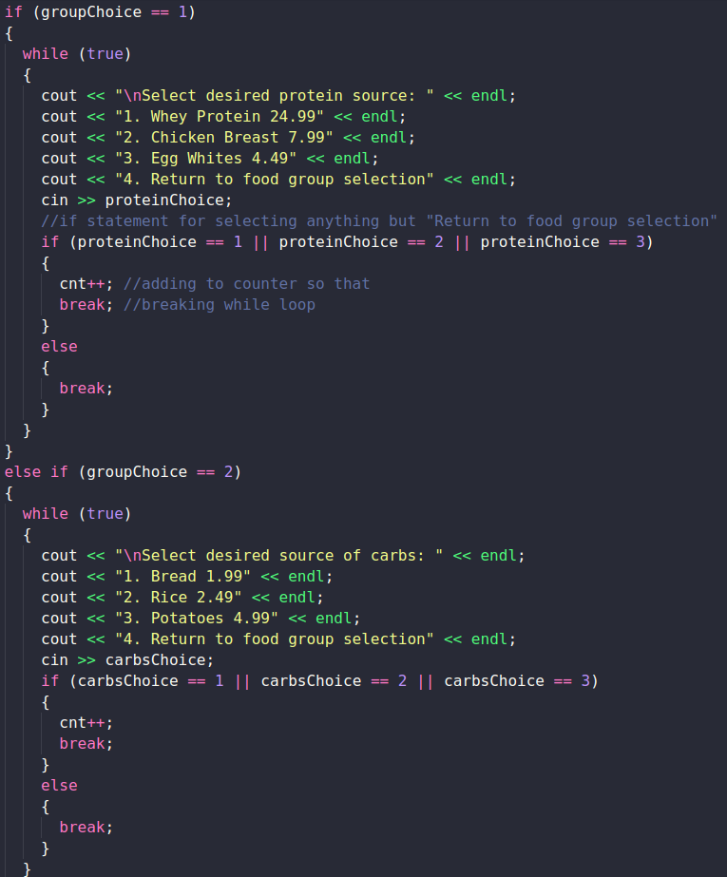

Picture 2 of 2

